(atharva㉿kali)-[~/Downloads/passord]

└─$ echo -e "Hello\nAtharva" > abc.txt

┌──(atharva㉿kali)-[~/Downloads/passord]

└─$ zip --password secret123 word.zip abc.txt

adding: abc.txt (stored 0%)

┌──(atharva㉿kali)-[~/Downloads/passord]

└─$ zip2john word.zip > ziphash.txt

ver 1.0 efh 5455 efh 7875 word.zip/abc.txt PKZIP Encr: 2b chk, TS_chk, cmplen=26, decmplen=14, crc=C24F23D4 ts=7F4A cs=7f4a type=0

┌──(atharva㉿kali)-[~/Downloads/passord]

└─$ sudo apt install wordlists

[sudo] password for atharva:

wordlists is already the newest version (2023.2.0).

wordlists set to manually installed.

The following packages were automatically installed and are no longer required:

ibverbs-providers libgfrpc0 libpython3.11-dev python3.11-dev

libboost-iostreams1.83.0 libgfxdr0 librados2 samba-ad-provision

libcephfs2 libglusterfs0 librdmacm1t64 samba-dsdb-modules

libgfapi0 libibverbs1 python3-lib2to3 samba-vfs-modules

Use 'sudo apt autoremove' to remove them.

Upgrading: 0, Installing: 0, Removing: 0, Not Upgrading: 2774

┌──(atharva㉿kali)-[~/Downloads/passord]

└─$ sudo gzip -d /usr/share/wordlists/rockyou.txt.gz

┌──(atharva㉿kali)-[~/Downloads/passord]

└─$ john ziphash.txt --wordlist=/usr/share/wordlists/rockyou.txt

Using default input encoding: UTF-8

Loaded 1 password hash (PKZIP [32/64])

Will run 2 OpenMP threads

Press 'q' or Ctrl-C to abort, almost any other key for status

secret123 (word.zip/abc.txt)

1g 0:00:00:00 DONE (2025-04-12 15:59) 50.00g/s 1024Kp/s 1024Kc/s 1024KC/s christal..michelle4

Use the "--show" option to display all of the cracked passwords reliably

Session completed.

┌──(atharva㉿kali)-[~/Downloads/passord]

└─$ john --show ziphash.txt

word.zip/abc.txt:secret123:abc.txt:word.zip::word.zip

1 password hash cracked, 0 left

**Summary**

1. **echo -e "Hello\nAtharva" > abc.txt**Creates a text file abc.txt with the content "Hello" and "Atharva" on separate lines.
2. **zip --password secret123 word.zip abc.txt**Creates a password-protected ZIP file word.zip containing abc.txt with the password secret123.

OR

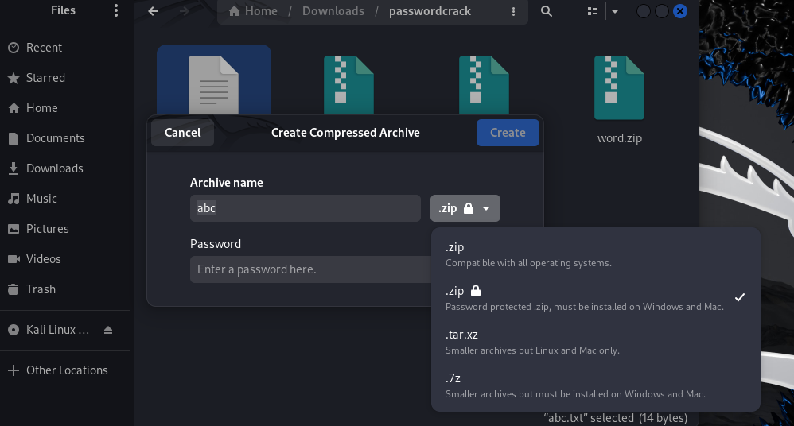Create a text file -> compress it and give password

1. **zip2john word.zip > ziphash.txt**Extracts the password hash from word.zip and saves it to ziphash.txt for cracking.
2. **sudo apt install wordlists**Installs the wordlists package containing wordlists for password cracking.
3. **sudo gzip -d /usr/share/wordlists/rockyou.txt.gz**Decompresses the rockyou.txt.gz wordlist to make it usable for cracking.
4. **john ziphash.txt --wordlist=/usr/share/wordlists/rockyou.txt**Uses john to crack the password hash in ziphash.txt with the rockyou.txt wordlist.
5. **john --show ziphash.txt**Displays the cracked password for the ZIP file from the hash in ziphash.txt.